Virginia Film Festival 2016

Filming at the Borders:
Migrating to Europe Today
(a selection of films curated by Nora Philippe)

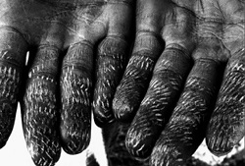

Sponsored by the UVA Department of French and
the UVA Program in European Studies

These films invite dialogue about the urgent topic of migration and about the role that images and narratives play in bringing it more fully to our awareness.

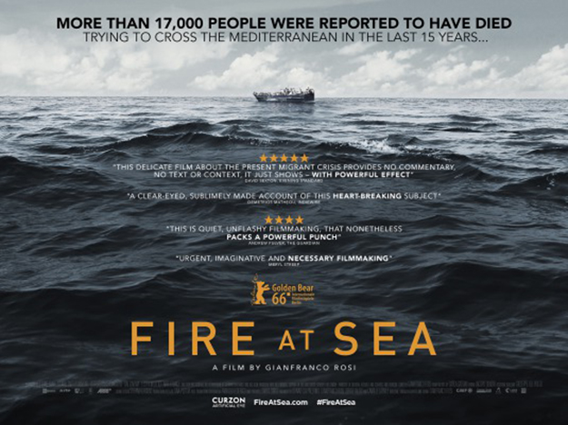

Fire at Sea, ( “Fuocoammare”), dir. Gianfranco Rosi (2016), 109 min.
Documentary/fiction. Italian-French co-production. Filmed in: Italy. Language: Italian, with English subtitles
In this stellar documentary, Gianfranco Rosi contrasts the lives of the desperate thousands (mostly African refugees) landing on the shores of the Sicilian island of Lampedusa with the everyday existence of the locals. Winner of Berlin Festival’s Golden Bear award.
A tiny island no more than eight square miles in size, Lampedusa has long been a Mediterranean toehold for people on the move, from ancient Greek and Roman sailors until now, as African migrants take advantage of its position roughly halfway between Libya and Sicily to make their first contact with European soil. These refugees now number more than 150,000 a year, crossing illegally in crowded boats — a phenomenon seen often enough on European news, usually when things go tragically amiss. But what of those who call this isolated location home? In “Fire at Sea,” documentary filmmaker Gianfranco Rosi turns his eye on the locals, most notably a 12-year-old boy named Samuele, whose lives have been transformed both directly and indirectly by a migrant problem far too large for the minuscule community to handle, addressing the crisis in humanist terms via a delicate, decidedly noncommercial cine-poem.
Also see:
- https://www.theguardian.com/film/2016/jun/09/fire-at-sea-review-masterly-and-moving-look-at-the-migrant-crisis
- Trailer https://www.youtube.com/watch?v=f8Kc5wy0Rxg

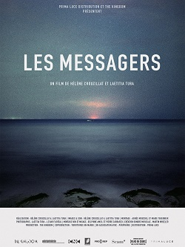
The Messengers (Les Messagers), Helene Crouzillat + Laetitia Tura (2015) 70 min
Documentary. French production. Filmed in: Morocco, Tunisia, Spain, France. Languages: French, Arabic, Spanish, Pulaar, with English subtitles.
From the Sahara to Melilla, migrants relate how they narrowly escaped death, unlike their unfortunate travelling companions – who were literally and symbolically swallowed up by the border: from the Mediterranean Sea’s waters to the walls that states have built at great expense. Where are their bodies? Where are their graves? The “messengers” are those who have survived and who say their names.
The Messengers is the very first documentary on the subject and was shot during a four-year long investigation in Northern Africa by the two directors, Tura being a filmmaker,and Crouzillat initially a photographer. Out of hundreds of hours of interviews, the two directors edited the film with a respectful restraint and a formal simplicity which convey a sense of political and metaphysical scandal. The film was theatrically released in France in 2015 after being selected at Cinéma du réel in Paris and Etats généraux du documentaire in Lussas, and it has been screened in many festivals in Europe and in Northern and Central Africa.
“The focus is on how the unburied dead challenge European policy responses. The film shows that, in some ways, the notion of the frontier covers that of a common grave: a crack engulfing an unwanted humanity whose only relic seems to be the words of the ‘messengers’.” (Charlotte Garson)
Also see:
- Trailer : https://www.youtube.com/watch?v=axaLwR8nblY
- http://leblogdocumentaire.fr/les-messagers-filmer-la-disparition-par-helene-crouzillat-et-laetitia-tura/

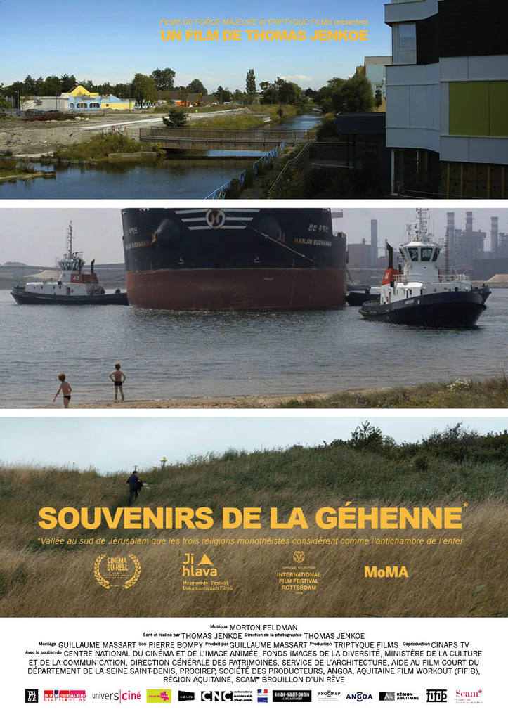
Memories From Gehenna (Souvenirs de la Géhenne), dir.Thomas Jenkoe (2015), France , 56 min.
More than a decade after a local man gunned down a North African immigrant, director Jenkoe visits the suburban port of Grande-Synthe in Northern France (not far away from Calais and Le Havre) and finds a town still deeply scarred. Jenkoe’s camera tours the town but keeps a respectful distance, while a soundtrack of interviews with locals and police tapes of the murderer’s interrogation creates a timely, shattering portrait of how fear and hate corrupt.
With a voice-over reading statements from the case file that he was exceptionally allowed to access, Jenkoe interlaces impressive shots of the urban landscape and on-the-spot testimonies, stories, rumors, comments. The weave becomes tighter and tighter and what first appear to be no more than architectural features help to construct the diabolical dramaturgy of “Gehenna.” Rarely has a news item been so deeply explored both from the angle of the killer’s background and the daytime and night-time filming of a town “hemmed in” by an immense metallurgical industrial complex (ArcelorMittal). While the editing and sound echo the amalgamation that results in irreparable damage, they create a tension between scales, which cinematographically recreates a contemporary malaise extending far beyond the boundary of Grande-Synthe. C Garson
Also see:
- Trailer : https://www.youtube.com/watch?v=ujNlLK_L07A
- http://www.dokument-festival.com/database/movie/21849%7CSouvenirs-de-la-Gehenne
- http://dafilms.com/film/9908-souvenirs-de-la-gehenne/

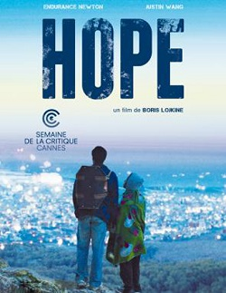
Hope, Boris Lojkine (2015), France, 86 min.
Fiction, Drama. French production. Filmed in: Morocco. Languages: French, English, Arabic, Lingala, Wolof, and more, with English subtitles.
In Hope, his first fiction film, the documentary film maker Boris Lojkine retraces the itinerary of a Nigerian woman and a Cameroonian man en route to Europe. A unique love story told against the background of the “ghettos.” the clandestine camps through which migrants transit.
Deep in the Sahara desert, as they try to get to Europe, Léonard, a young man from Cameroon, rescues Hope, a Nigerian woman. In a fiercely hostile world where safety requires staying with one’s own people, these two try to find their way together, and to love each other.
Hope premiered at the Cannes Film Festival (Semaine de la Critique, SACD award) and was theatrically released in France in 2015, after having been widely shown around the world, and specifically on the African continent. The two leading actors won awards at Tübingen Festival. Lojkine had directed award-winning documentaries about Vietnam before shooting this first feature film. For Hope, he exclusively worked with non-professional actors whom he cast for several months in Rabat among the migrants, while finishing the script. Shot in Morocco and in a dozen languages, Hope describes the underground world of migration from the inside, the business it relies on, and the extreme gender-based violence. “Boris Lojkine filmed Sub-Saharan migration in a way that has never been shown before. A complete shock.” (Le Point)
Also see:
- Excerpt: https://www.youtube.com/watch?v=IsFddteGm6s
- http://www.hollywoodreporter.com/review/hope-cannes-review-705847
- http://inter.pyramidefilms.com/content/hope
- http://variety.com/2014/film/festivals/film-review-hope-1201206198/
- http://brightlightsfilm.com/the-world-of-the-road-is-a-state-of-exception-boris-lojkine-hope-explores-the-world-of-african-migrants/
- http://www.lemonde.fr/m-actu/article/2015/01/23/boris-lojkine-hope-et-ses-amours-errantes_4561397_4497186.html

